# Performance Report

# Google Search Console Results:

# 

# Google ranked this pages on 1st page of Search bar

You can try yourself. Below, these pages are on the first page of Google.

Just type on Google **lemfort**  and see it on the first page

* Lemfort House of Apparel
* Men’s Jackets
* Shop
* Accessories
* Latest products
* Facebook page
* Lemfort website’s images

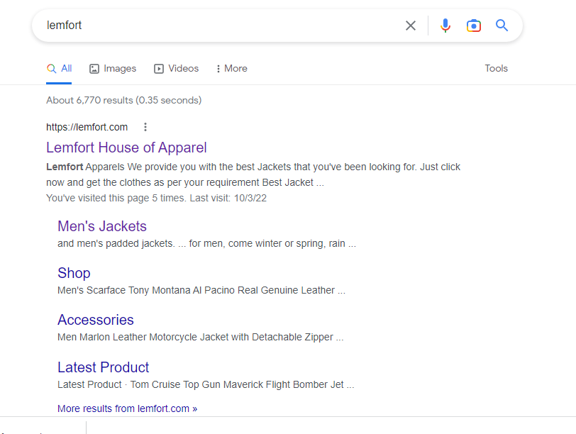

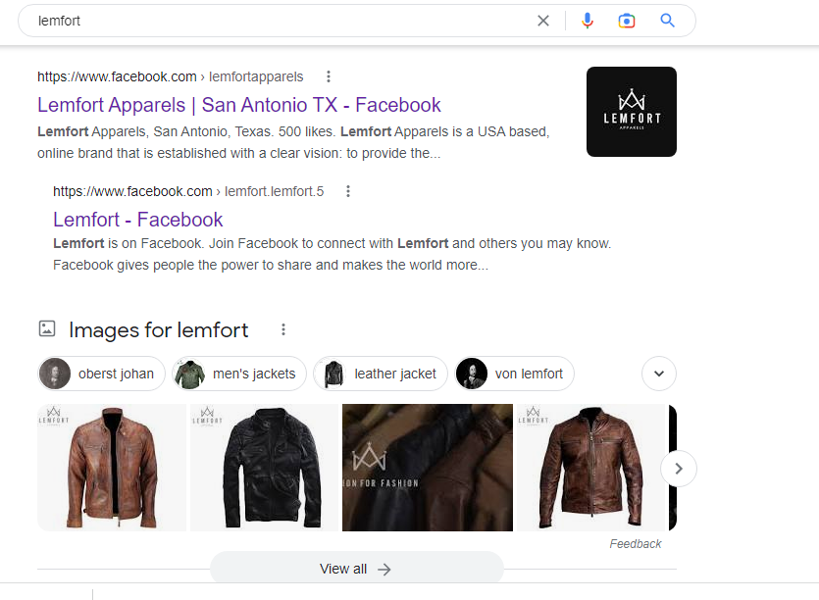

# Page indexing

From 0 to 109 pages are now indexed.

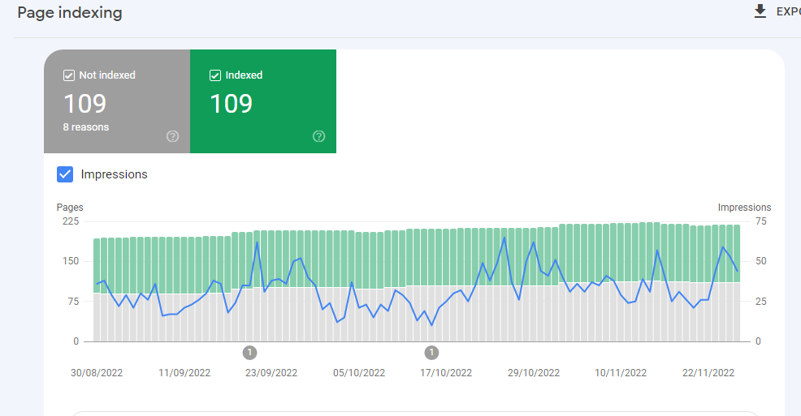

# Sitemap status (success)

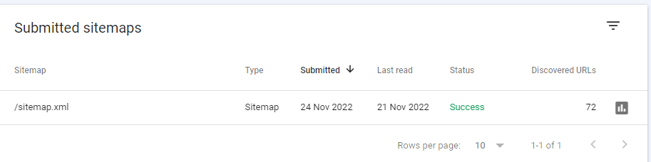

# 100% Mobile friendly and usability

# Product base Crawling

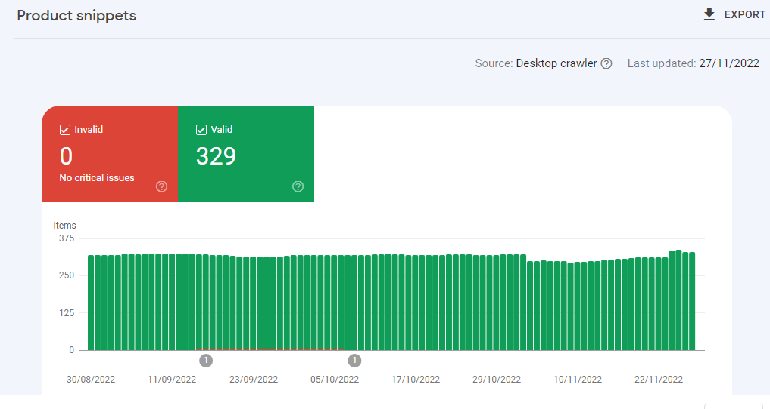

# Organic keywords

From 2 to 46 + 25 (Still increasing)

90% keywords are ranked in USA.

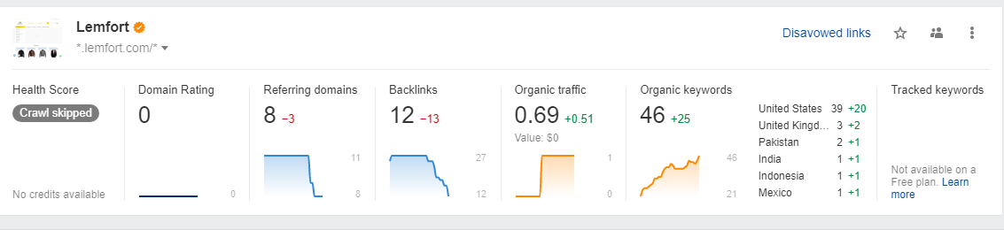

# Traffic from last 3 months till now

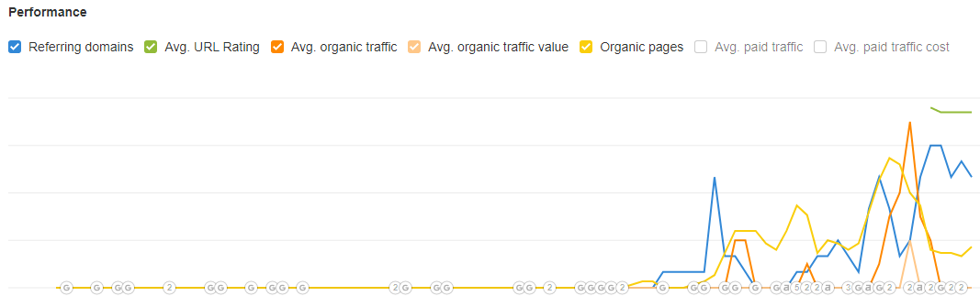

# Traffic in USA

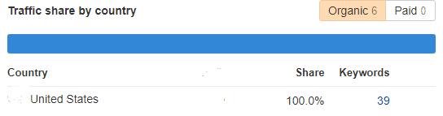

# OTHER services for Lemfort

* Back-up
* Site map
* SEO based Content writing and image SEO
* Google crawling and indexing
* Sitemap
* Verification by head tag of lemfort to google search console
* Consultancy
* Verified website by Google webmaster tool
* Competitor analysis
* Mobile friendly and delete mobile accessories lists and items
* SEO based keywords by google keyword planner etc.